easy read form
Telling the optometrist about me
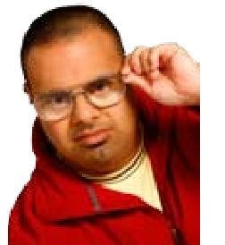
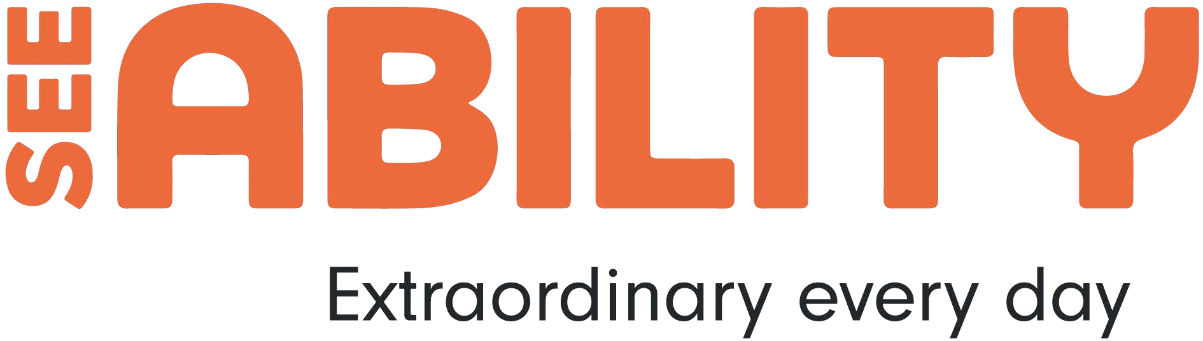
Information about me and my sight
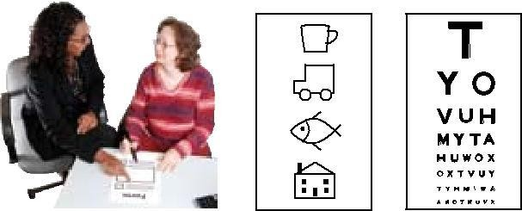
Please fill in this form and take it with you to your eye test

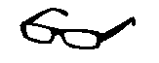
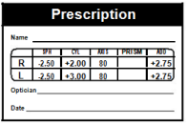
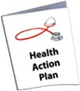
Your supporter can fill in this form with you. It’s okay to ask them to write on the form

- Your glasses if you have any
- The prescription from your last eye test
- Evidence of any benefits you get
- Your Health Action Plan if you have one

Please also take these things with you to your eye test:

Phone number:
Email address:
Your name and role:
Your address:
If you are filling in this form for someone else please fill in this section

SeeAbility is the operating name of The Royal School for the Blind founded in 1799. Registered Charity Number 255913 © SeeAbility 2017. No part of this document can be altered or changed without permission

Page 1

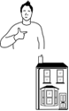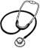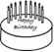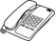

Phone number: Date of birth: NHS Number:
National Insurance Number
Your GPs name and address
Your name:
Your address:
Your details:

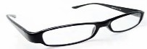
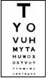
About your eyes:

Where and when was your last eye test?

Tell us the results of your eye test

Do you have glasses? Yes no don’t know

If yes, please take your glasses with you to the eye test.
Tell us what you wear your glasses for

Do you have any problems

with your glasses? yes no
Tell us about any problems

with your glasses
don’t know

SeeAbility is the operating name of The Royal School for the Blind founded in 1799. Registered Charity Number 255913 © SeeAbility 2017. No part of this document can be altered or changed without permission

Page 2

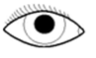
Do you have any
yes no

problems seeing? don’t know

If yes, please write what the problems are?

Are you registered blind/

sometimes

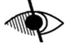
severely sight
impaired?
Are you registered partially sighted/sight impaired?

Have you ever been to hospital about problems yes with your eyes?
yes no

yes

yes
no don’t know

no don't know

no don't know

If yes,

- what was the problem?
- which hospital did you go to?

Has anyone in your family

had serious eye problems? yes
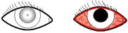
For example: has anyone had glaucoma, cataracts or diabetes?

no don't know

If yes, please write say who has the problems and what
problems they’ve had

Who | What problem

SeeAbility is the operating name of The Royal School for the Blind founded in 1799. Registered Charity Number 255913 © SeeAbility 2017. No part of this document can be altered or changed without permission

Page 3

More about you
More about you
Do you use a
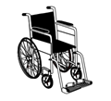
wheelchair? yes no sometimes

If yes, ask about access into the optician shop and the eye test room

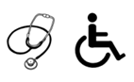
Do you have any
health problems yes no
or disabilities?

If yes, please say
what they are

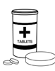
Do you take any
medication?

yes no don’t know

If yes, please take information about your medication with you to the eye test
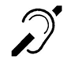
Are you Deaf or

Hard of hearing? yes no
If yes, please tell the optometrist about your hearing
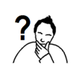
Do you find it

hard to communicate?
yes no sometimes

What helps you communicate? Tell us if you use things like: Makaton, an interpreter, pictures, gestures, closed questions with yes/no answers

SeeAbility is the operating name of The Royal School for the Blind founded in 1799. Registered Charity Number 255913 © SeeAbility 2017. No part of this document can be altered or changed without permission

Page 4

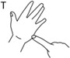
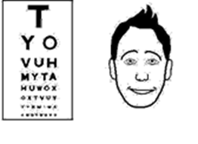
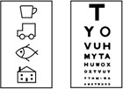
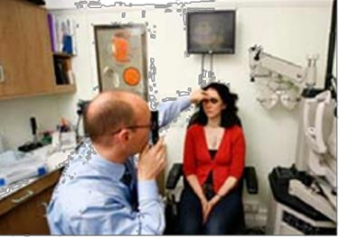
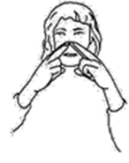
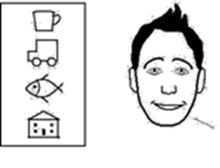
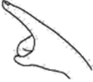
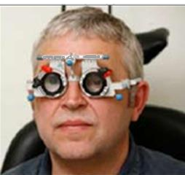
About your eye test
When you have your eye test the optometrist will need to look at your eyes. They will also do some tests to check how well you can see.
The information you give the optometrist will help them to test your eyes.
Can you say or sign the names of the letters on an eye test chart?

yes no don't know

Can you say or sign names of pictures on a chart like house, fish or car?

yes no don't know

Can you point to a letter or picture on a card that is the same as a letter or picture on a chart on a wall?

yes no don't know

Will you be able to wear test frames your face?
yes no don't know

SeeAbility is the operating name of The Royal School for the Blind founded in 1799. Registered Charity Number 255913 © SeeAbility 2017. No part of this document can be altered or changed without permission.

Page 5

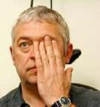
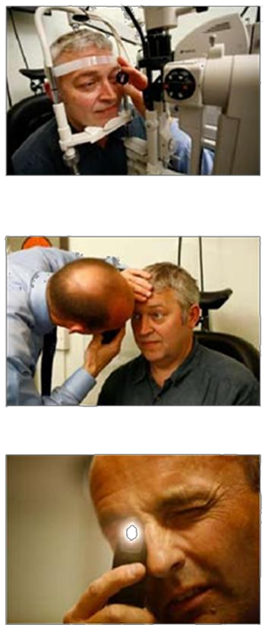
Will you be okay if the optometrist were to cover your eyes one at a time?
yes no don't know

Can you understand ‘better’ and ‘worse’?

yes no don't know

Would you be able to put your chin on a shelf in front of a machine?
You will need to keep your head still for while
yes no don't know

Will you be okay if the optometrist came close to you?

yes no don't know

Will you be okay if the optometrist came close to you and shone a bright light in your eye?

yes no don't know

SeeAbility is the operating name of The Royal School for the Blind founded in 1799. Registered Charity Number 255913 © SeeAbility 2017. No part of this document can be altered or changed without permission

Page 6

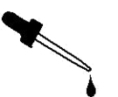
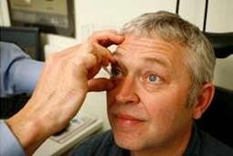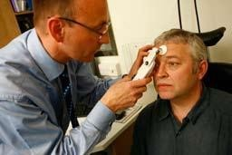

don't know
no
yes
Will you be okay if the optometrist needs to put drops in your eyes?
Some eye drops may sting for a bit, or make it hard to see for a short time.
You can ask the optometrist about this
don't know
no
yes
Will you be okay with a machine that will measure your eye pressure?
This machine might blow air into your eye or gently touch your eye. This will not hurt but it might make you jump
Please tell us any other information we may need to know here

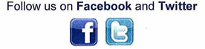
www.seeability.org

Reviewed: November 2017

SeeAbility is the operating name of The Royal School for the Blind founded in 1799. Registered Charity Number 255913 © SeeAbility 2017. No part of this document can be altered or changed without permission

Page 7

